

**DEPARTMENT OF CSE**

|  |
| --- |
| Photograph  Passport Size |

**B.Tech. CSE**

**STUDENT LAB REPORT SHEET**

**Name of Student: Rashmi Kuliyal Mob.No.:7452093546**

**Address Permanent:Battery Farm ,Shyampur, Rishikesh,Dehradun**

**Father’s Name:Mr. Manoj Kuliyal Occupation:Merchant Navy Mob.No:7060452093**

**Mother’s Name: Seema Devi Occupation:Housewife Mob.No: 8218928655**

**Section: A Branch: CSE Semester: 3 Class Roll No:49 Grade A B C**

**Local Address:Battery farm,Shyampur,Rishikesh,Dehradun Email:rashmikuliyal543@gmail.com Marks 5 3 1**

|  |  |  |  |  |  |  |  |  |
| --- | --- | --- | --- | --- | --- | --- | --- | --- |
| **S.No.** | **Practical** | **D.O.P.** | **Date of Submission** | **Grade (Viva)** | **Grade (Report File)** | **Total Marks (out of 10)** | **Student’s Signature** | **Teacher’s Signature** |
| **1** | **Practical-01** |  |  |  |  |  |  |  |
| **2** | **Practical-02** |  |  |  |  |  |  |  |
| **3** | **Practical-03** |  |  |  |  |  |  |  |
| **4** | **Practical-04** |  |  |  |  |  |  |  |
| **5** | **Practical-05** |  |  |  |  |  |  |  |
| **6** | **Practical-06** |  |  |  |  |  |  |  |
| **7** | **Practical-07** |  |  |  |  |  |  |  |
| **8** | **Practical-08** |  |  |  |  |  |  |  |
| **9** | **Practical-09** |  |  |  |  |  |  |  |
| **10** | **Practical-10** |  |  |  |  |  |  |  |
| **11** | **Practical-11** |  |  |  |  |  |  |  |
|  |  |  |  |  |  |  |  |  |



Table of Contents

|  |  |  |
| --- | --- | --- |
| **Program No.** | **Program Name** | **Page No** |
| 1 | **P1_Task-01_NamespaceInC++** |  |
| 2 | **P1_Task-02_PrimeOrNot** |  |
| 3 | **P2_Task-01_DataTypesInC++** |  |
| 4 | **P2_Task-02_OperatorsInC++** |  |
| 5 | **P3_Task-01_ArrayInC++** |  |
| 6 | **P4_Task-01_StringInC++** |  |
| 7 | **P5_Task-01_PointersInC++** |  |
| 8 | **P6_Task-01_FunctionsInC++** |  |
| 9 | **P7_Task-01_ClassAndObjectInC++** |  |

|  |  |  |
| --- | --- | --- |
| 10 | **P7_Task-01_ClassAndObjectInC++** |  |
| 11 | **P7_Task-02_ClassAndObjectInC++** |  |
| 12 | **P7_Task-03_ClassAndObjectInC++** |  |
| 13 | **P8_Task-01_ConstructorInC++** |  |
| 14 | **P9_Task-01_StaticDataMembersInC++** |  |
| 15 | **P10_Task-01_OperatorOverloadingInC++** |  |
| 16 | **P10_Task-02_OperatorOverloadingInC++** |  |
| 17 | **P11_Task-01_PointerToClassInC++** |  |

**Program 1/Task-01**

**Source Code:**

#include<iostream>

using namespace std;

/* localscope -> global scope ->namespace!

*/

namespace std1{

    int x=10;

}

namespace std2{

    int x=12;

}

int x=15;

int main()

{

cout<< std1::x<<endl;

cout<< std2::x<<endl;

cout<<x<<endl;

return 0;

}

**OUTPUT:**

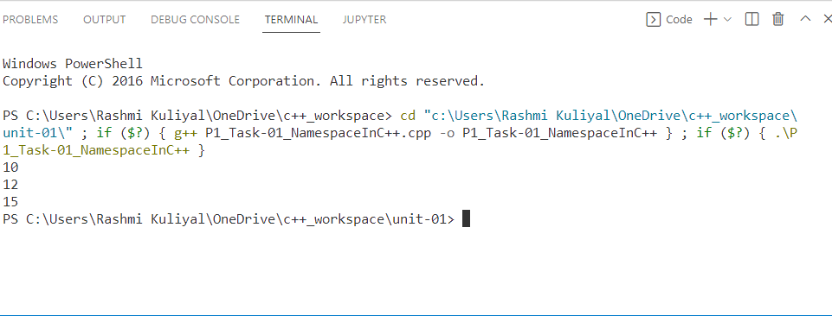

**Program 1/Task-02**

#include <iostream>

#include <cmath>

using namespace std;

void forAllNPrimeOrNot(int n);

void forHalfNPrimeOrNot(int n);

void forSqrtNPrimeOrNot(int n);

void forSqrt1NPrimeOrNot(int n);

int sqrt1(int n);

int main()

{

    int n, a;

    cout << "enter no:";

    cin >> n;

    forAllNPrimeOrNot(n);

    forHalfNPrimeOrNot(n);

    forSqrtNPrimeOrNot(n);

    forSqrt1NPrimeOrNot(n);

    return 0;

}

void forAllNPrimeOrNot(int n)

{

    int i;

    int b = 1;

    for (i = 2; i < n; i++)

    {

        if (n % i == 0)

        {

            b = 0;

            break;

        }

    }

    if (b)

    {

        cout << "Number is prime" << endl;

    }

    else

    {

        cout << "Not Prime" << endl;

    }

}

void forSqrtPrimeOrNot(int n)

{

    int i;

    int b = 1;

    for (i = 2; i <= sqrt(n); i++)

    {

        if (n % i == 0)

        {

            b = 0;

            break;

        }

    }

    if (b)

    {

        cout << "number is prime" << endl;

    }

    else

    {

        cout << "not prime" << endl;

    }

}

void forHalfNPrimeOrNot(int n)

{

    int i;

    int b = 1;

    for (i = 2; i <= n / 2; i++)

    {

        if (n % i == 0)

        {

            b = 0;

            break;

        }

    }

    if (b)

    {

        cout << "number is prime" << endl;

    }

    else

    {

        cout << "not prime" << endl;

    }

}

int  sqrt1(int n)

{

    int i = 1;

    int r = 1;

    while (r <= n)

    {

        i++;

        r = i * i;

    }

    return (i - 1);

}

void forSqrt1PrimeOrNot(int n)

{

    int i;

    int b = 1;

    int s = sqrt1(n);

    for (i = 2; i <= s; i++)

    {

        if (n % i == 0)

        {

            b = 0;

            break;

        }

    }

    if (b)

    {

        cout << "no is prime" << endl;

    }

    else

    {

        cout << "not prime" << endl;

    }

}

**OUTPUT**

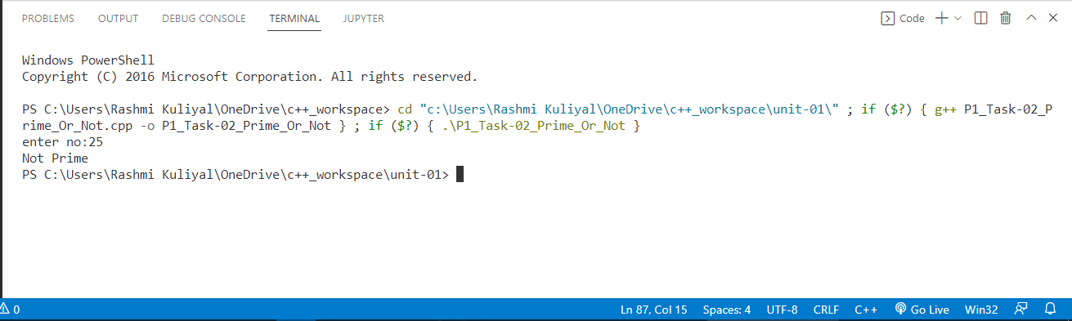

**PROGRAM-2/TASK-01**

#include<iostream>

using namespace std;

int main()

{

    cout<<"char:"<<sizeof(char)<<endl;

    cout<<"short:"<<sizeof(short)<<endl;

    cout<<"int:"<<sizeof(int)<<endl;

    cout<<"long:"<<sizeof(long int)<<endl;

    cout<<"float:"<<sizeof(float)<<endl;

    cout<<"double:"<<sizeof(double)<<endl;

    cout<<"wide character:"<<sizeof(wchar_t)<<endl;

    return 0;

}

**OUTPUT:**

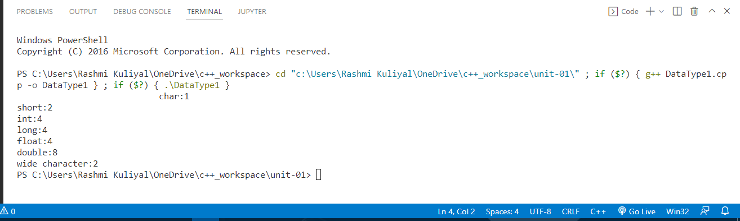

**PROGRAM-2/Task-01**

#include<iostream>

#include<climits>

using namespace std;

int main()

{

    cout<<"INT_MAX: "<<INT_MAX<<endl;

    cout<<"INT_MIN: "<<INT_MIN<<endl;

    cout<<"LONG_MAX: "<<LONG_MAX<<endl;

    cout<<"LONG_MIN: "<<LONG_MIN<<endl;

}

**OUTPUT:**

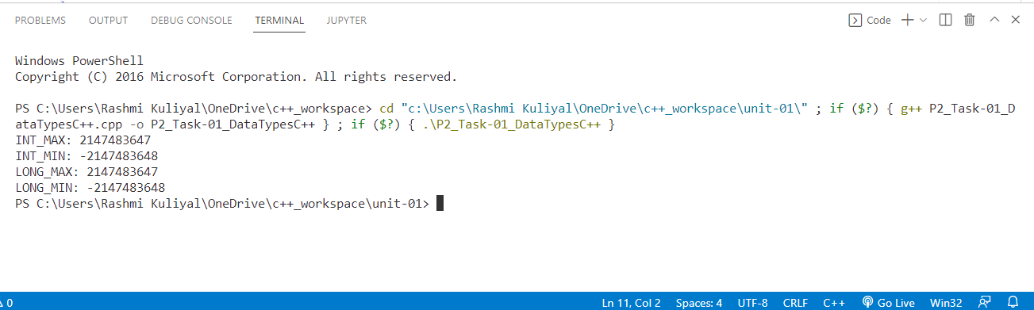

**PROGRAM-2/Task-02**

#include<iostream>

using namespace std;

int main()

{

int a=10;

int b=12;

//Arithmetic Operators[+,-,*,/]

cout<<a+b<<endl;

cout<<a-b<<endl;

cout<<a*b<<endl;

cout<<a/b<<endl;

//Remainder 0r Modulus  Operator[%]

cout<<a%b<<endl;

//Arithmetic Assignment Operators

int c=10;

c+=a;

cout<<a<<endl;

//Increment And Decrement Operator  [++ , --]

cout<<a++<<endl;

cout<<a++<<endl;

cout<<a--<<endl;

cout<<--a<<endl;

//logical operators[&&,||,!]

if(a>1 && b<2)

{

    cout<<"inside if 1"<<endl;

}

if(a>1||b<2)

{

    cout<<"inside if 2"<<endl;

}

if(a!=2)

{

    cout<<"inside if 3"<<endl;

}

//Bitwise operators

cout<< (a&b)<<endl;

cout<< (a|b) <<endl;

cout<< ~a  <<endl;

if(a>1&b<2)

{

    cout<<a<<endl;

}

//Conditional or Ternary Operator(  ?   )

int n1=5,n2=10,max;

max=(n1>n2)?n1:n2;

cout<<"Largest number between n1 and n2: "<<max<<endl;

//Relational Operators [<,>,<=,>=]

if(n1>1)

{

    cout<<n1<<endl;

}

return 0;

}

**OUTPUT:**

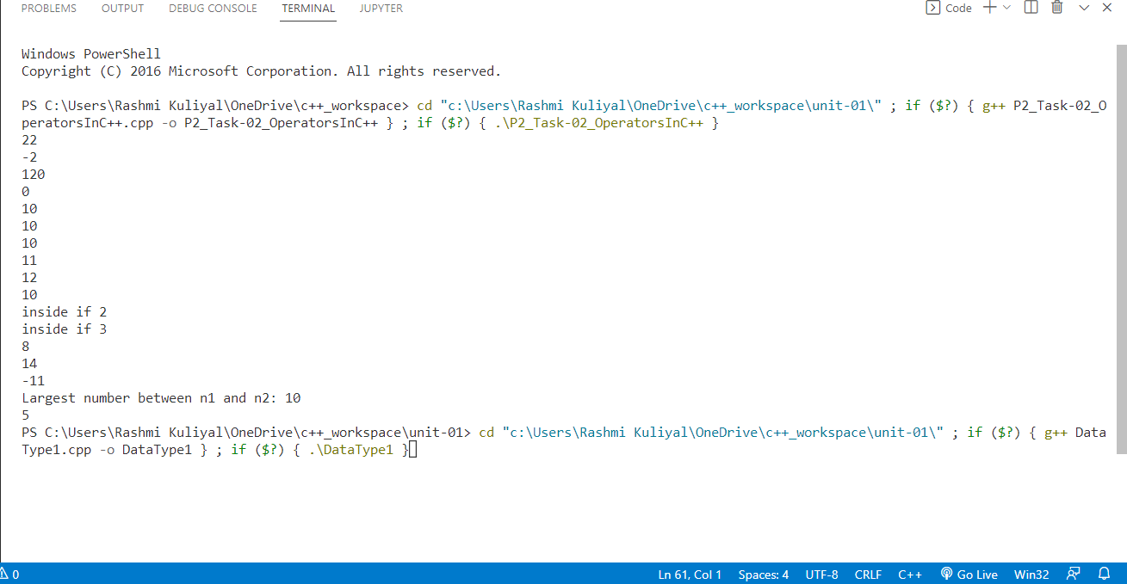

**PROGRAM-03/Task-01**

void delete1()

{   int n=8;

    int arr[n]={1,2,3,4,5,6,7,8};

    int k=4;

    for(int i=0;i<n;i++)

    {

        if(arr[i]==k)

        {

            while(i<n)

            {

               arr[i]=arr[i+1];

               i++;

            }

            break;

        }

    }

     for(int i=0;i<n-1;i++)

    {

        cout<<arr[i]<<" ";

    }

}

void delete2()

{    int n=8;

     int k=4;

    int arr[n]={1,2,3,4,5,6,7,8};

    int j=0;

    for(int i=0;i<n;i++)

    {

       if(arr[i]==k)

       {

        continue;

       }

       else

       {

        arr[j++]=arr[i];

       }

    }

    for(int i=0;i<n-1;i++)

    {

        cout<<arr[i]<<" ";

    }

}

void delete3()

{

    int n=8,j=0;

    int arr[n]={1,2,3,4,5,6,7,8};

    int arr2[n-1];

    int k=4;

    for(int i=0;i<n;i++)

    {

        if(arr[i]==k)

        {

            continue;

        }

        else

        {

           arr2[j++]=arr[i];

        }

    }

     for(int i=0;i<n-1;i++)

    {

        cout<<arr2[i]<<" ";

    }

}

**OUTPUT:**

